

**DEPARTMENT OF COMPUTER ENGINEERING**

DBMS LAB REPORT

By Mrs. Vaishali Jorwekar

Download Oracle setup from below link: <https://www.oracle.com/database/technologies/xe-downloads.html>

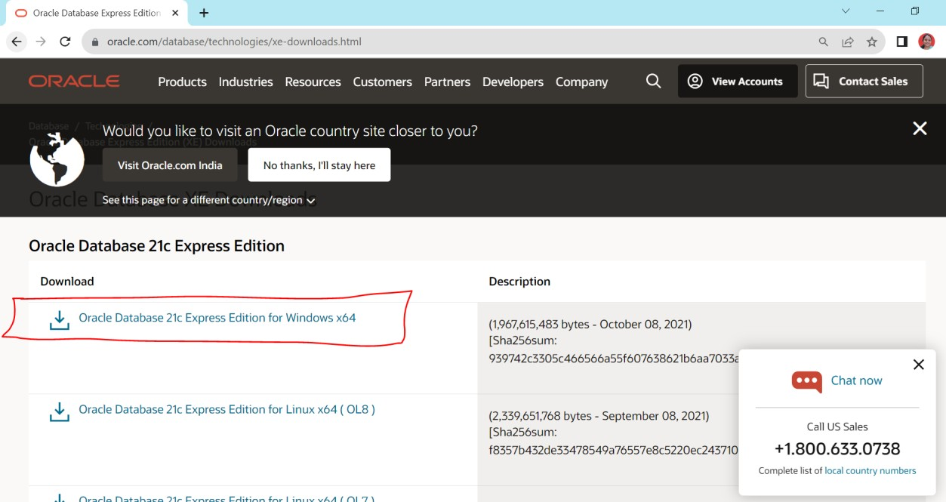

By Mrs. Vaishali Jorwekar

**Assignment 2**

**Design and Develop SQL DDL statements which demonstrate the use of SQL objects such as Table, View, Index, Sequence, Synonym**

SQL> create table client_master(client_no int, client_name varchar(20),address varchar(50),city varchar(10), pincode int, state varchar(20),bal_due float,primary key(client_no));

Table created.

SQL> insert into client_master values('001','abhi','nasik','nasik','422004','MH','5000');

1 row created.

SQL> insert into client_master values('002','piyu','nasik','nasik','422004','MH','10000');

1 row created.

SQL> insert into client_master values('003','abd','nasik','nasik','422003','MH','5000');

1 row created.

SQL> insert into client_master values('004','abd','nasik','nasik','422003','MH','5000');

1 row created.

SQL> insert into client_master values('005','abc','nasik','nasik','422003','MH','5000');

1 row created.

SQL> select * from client_master;

|  |  |  |  |  |  |  |  |
| --- | --- | --- | --- | --- | --- | --- | --- |
| CLIENT_NO | CLIENT_NAME | ADDRESS | CITY | PINCODE |  | STATE | BAL_DUE |
| 1 | abhi | nasik | nasik | 422004 |  | MH | 5000 |
| 2 | piyu | nasik | nasik | 422004 |  | MH | 10000 |
| 3 | abd | nasik | nasik | 422003 |  | MH | 5000 |
| 4 | abd | nasik | nasik | 422003 |  | MH | 5000 |
| 5 | abc | nasik | nasik | 422003 |  | MH | 5000 |

SQL> select client_name, client_no from client_master; CLIENT_NAME CLIENT_NO

abhi 1

piyu 2

abd 3

abd 4

abc 5

SQL> insert into client_master values('006','xyz','nasik','nasik','422004','MH','6000');

1 row created.

SQL> select client_name, client_no from client_master; CLIENT_NAME CLIENT_NO

|  |  |  |
| --- | --- | --- |
| abhi |  | 1 |
| piyu |  | 2 |
| abd |  | 3 |
| abd |  | 4 |
| abc |  | 5 |
| xyz |  | 6 |
| 6 rows | selected. |  |

SQL> create table product_master (product_no int, description varchar (20), profit_per float, unit_measure varchar (10), quantity int, reorder int, sell_price float, cost_price float, primary key(product_no));

Table created.

SQL> insert into product_master values('001','shampoo','1','one','4','2','10','15');

1 row created.

SQL> insert into product_master values('002','oil','13','one','4','2','11','16');

1 row created.

SQL> alter table client_master add telephone_no int; Table altered.

SQL> select * from client_master;

CLIENT_NO CLIENT_NAME ADDRESS CITY PINCODE STATE BAL_DUE TELEPHONE_NO

|  |  |  |  |  |  |  |
| --- | --- | --- | --- | --- | --- | --- |
| 1 | abhi | nasik | nasik | 422004 | MH | 5000 |
| 2 | piyu | nasik | nasik | 422004 | MH | 10000 |
| 3 | abd | nasik | nasik | 422003 | MH | 5000 |
| 4 | abd | nasik | nasik | 422003 | MH | 5000 |

|  |  |  |  |  |  |
| --- | --- | --- | --- | --- | --- |
| 5 | abc | nasik | nasik 422003 | MH | 5000 |
| 6 | xyz | nasik | nasik 422004 | MH | 6000 |

6 rows selected.

SQL> select * from product_master;

|  |  |  |  |  |  |  |
| --- | --- | --- | --- | --- | --- | --- |
| PRODUCT_NO COST_PRICE | DESCRIPTION | PROFIT_PER | UNIT_MEASU | QUANTITY | REORDER | SELL_PRICE |
| 001 | shampoo | 1 | one | 4 | 2 | 10 |
| 15 |  |  |  |  |  |  |
| 002 | oil | 13 | one | 4 | 2 | 11 |
| 16 |  |  |  |  |  |  |

SQL> CREATE TABLE auto (

1. roll_no NUMBER GENERATED ALWAYS AS IDENTITY NOT NULL,
2. name VARCHAR2(20),
3. PRIMARY KEY (roll_no) 5 );

Table created.

SQL> select * from auto; no rows selected

SQL> INSERT INTO auto (name) VALUES ('abc');

1 row created.

SQL> INSERT INTO auto (name) VALUES ('adc');

1 row created.

SQL> CREATE SEQUENCE auto_sequence START WITH 100;

Sequence created.

SQL> select * from auto; ROLL_NO NAME

1. abc
2. adc

SQL> update client_master set client_name='nut' where client_no='4';

1 row updated.

SQL> select * from client_master;

CLIENT_NO CLIENT_NAME ADDRESS CITY PINCODE STATE BAL_DUE TELEPHONE_NO

|  |  |  |  |  |  |  |
| --- | --- | --- | --- | --- | --- | --- |
| 1 | abhi | nasik | nasik | 422004 | MH | 5000 |
| 2 | piyu | nasik | nasik | 422004 | MH | 10000 |
| 3 | abd | nasik | nasik | 422003 | MH | 5000 |
| 4 | nut | nasik | nasik | 422003 | MH | 5000 |
| 5 | abc | nasik | nasik | 422003 | MH | 5000 |
| 6 | xyz | nasik | nasik | 422004 | MH | 6000 |
| 6 rows | selected. |  |  |  |  |  |

SQL> create index client_find on client_master(client_name, city); Index created.

SQL> select * from product_master;

PRODUCT_NO DESCRIPTION PROFIT_PER UNIT_MEASU QUANTITY REORDER SELL_PRICE COST_PRICE

001 shampoo 1 one 4 2 10

15

002 oil 13 one 4 2 11

16

SQL> desc product_master;

Name Null? Type

|  |  |  |  |
| --- | --- | --- | --- |
| PRODUCT_NO | NOT | NULL | NUMBER(38) |
| DESCRIPTION |  |  | VARCHAR2(20) |
| PROFIT_PER |  |  | FLOAT(126) |
| UNIT_MEASURE |  |  | VARCHAR2(10) |
| QUANTITY |  |  | NUMBER(38) |
| REORDER |  |  | NUMBER(38) |
| SELL_PRICE |  |  | FLOAT(126) |
| COST_PRICE |  |  | FLOAT(126) |

SQL> alter table client_master rename to c_master; Table altered.

SQL> insert into product_master values('003','nutela','15','three','40','5','110','123');

1 row created.

SQL> create view client as select client_no,client_name from c_master; View created.

SQL> select * from client; CLIENT_NO CLIENT_NAME

1. abhi
2. piyu
3. abd
4. nut
5. abc
6. xyz

6 rows selected.

**Assignment 3**

**Design at least 10 SQL queries for suitable database application using SQL DML statements: all types of Joins, Sub-Query and View**

SQL> CREATE TABLE name(roll_no INT NOT NULL, name VARCHAR(30) NOT NULL,PRIMARY KEY (roll_no));

Table created.

SQL> INSERT INTO name VALUES(37 ,'INDRANEEL');

1 row created.

|  |  |  |  |  |
| --- | --- | --- | --- | --- |
| SQL> INSERT INTO  1 row created. | name | VALUES | (38 | ,'SHUBHAM'); |
| SQL> INSERT INTO  1 row created. | name | VALUES | (39 | ,'AKSHAY'); |
| SQL> INSERT INTO  1 row created. | name | VALUES | (40 | ,'SAKSHI'); |
| SQL> INSERT INTO  1 row created. | name | VALUES | (41 | ,'KETAN'); |

SQL> SELECT * FROM name; ROLL_NO NAME

1. INDRANEEL
2. SHUBHAM
3. AKSHAY
4. SAKSHI
5. KETAN

SQL> CREATE TABLE submission(sr_no INT NOT NULL, assgn_id VARCHAR(30),roll_no INT NOT NULL,PRIMARY KEY(sr_no));

Table created.

SQL> INSERT INTO submission VALUES (1,’YYYY’,37);

1 row created.

SQL> INSERT INTO submission VALUES (2,’YXYY’,37);

1 row created.

SQL> INSERT INTO submission VALUES (3,’YXYY’,38);

1 row created.

SQL> INSERT INTO submission VALUES (4,'YXYY’,39);

1 row created.

SQL> SELECT * FROM submission;

SR_NO ASSGN_ID ROLL_NO

1. YYYY 37
2. YXYY 37
3. YXYY 38
4. YXYY 39

SQL> ALTER TABLE submission ADD FOREIGN KEY (roll_no) REFERENCES name(roll_no);

Table altered.

SQL> desc submission

Name Null? Type

SR_NO NOT NULL NUMBER (38)

ASSGN_ID VARCHAR2(30)

ROLL_NO NOT NULL NUMBER (38)

SQL> SELECT * FROM name, submission WHERE name.roll_no=submission.roll_no; ROLL_NO NAME SR_NO ASSGN_ID ROLL_NO

|  |  |  |  |  |
| --- | --- | --- | --- | --- |
| 37 | INDRANEEL | 1 | YYYY | 37 |
| 37 | INDRANEEL | 2 | YXYY | 37 |
| 38 | SHUBHAM | 3 | YXYY | 38 |
| 39 | AKSHAY | 4 | YXYY | 39 |

SQL> SELECT * FROM name JOIN submission ON name.roll_no=submission.roll_no; ROLL_NO NAME SR_NO ASSGN_ID ROLL_NO

|  |  |  |  |  |
| --- | --- | --- | --- | --- |
| 37 | INDRANEEL | 1 | YYYY | 37 |
| 37 | INDRANEEL | 2 | YXYY | 37 |
| 38 | SHUBHAM | 3 | YXYY | 38 |
| 39 | AKSHAY | 4 | YXYY | 39 |

SQL> SELECT name.roll_no, name, assgn_id FROM name INNER JOIN submission ON name.roll_no = submission.roll_no;

ROLL_NO NAME ASSGN_ID

37 INDRANEEL YYYY

1. INDRANEEL YXYY
2. SHUBHAM YXYY
3. AKSHAY YXYY

SQL> SELECT * FROM name LEFT JOIN submission ON name.roll_no=submission.roll_no;

ROLL_NO NAME SR_NO

ASSGN_ID ROLL_NO

37 INDRANEEL 1

YYYY 37

1. INDRANEEL 2

YXYY 37

1. SHUBHAM 3

YXYY 38

ROLL_NO NAME SR_NO

ASSGN_ID ROLL_NO

1. AKSHAY 4

YXYY 39

1. SAKSHI
2. KETAN

6 rows selected.

SQL> SELECT name.roll_no, submission.assgn_id

1. FROM name
2. LEFT JOIN submission ON name.roll_no = submission.roll_no;

ROLL_NO ASSGN_ID

37 YYYY

1. YXYY
2. YXYY
3. YXYY 40

41

6 rows selected.

SQL>

SQL> SELECT * FROM name RIGHT JOIN submission ON name.roll_no=submission.roll_no;

ROLL_NO NAME SR_NO

ASSGN_ID ROLL_NO

37 INDRANEEL 1

YYYY 37

1. INDRANEEL 2

YXYY 37

1. SHUBHAM 3

YXYY 38

ROLL_NO NAME SR_NO

ASSGN_ID ROLL_NO

1. AKSHAY 4

YXYY 39

SQL> CREATE TABLE a3_info(roll_no INT NOT NULL, name VARCHAR(30),cs_lang VARCHAR(30),PRIMARY KEY (roll_no));

Table created.

SQL> INSERT INTO a3_info VALUES(37,'INDRANEEL','SQL');

1 row created.

SQL> INSERT INTO a3_info VALUES(40,'SAKSHI','C++');

1 row created.

SQL> INSERT INTO a3_info VALUES(38,'SHUBHAM','PYTHON');

1 row created.

SQL> INSERT INTO a3_info VALUES(39,'AKSHAY','JAVA');

1 row created.

SQL> INSERT INTO a3_info VALUES(41,'KETAN','REACT');

1 row created.

SQL> SELECT * FROM a3_info;

ROLL_NO NAME CS_LANG

37 INDRANEEL SQL

40 SAKSHI C++

1. SHUBHAM PYTHON
2. AKSHAY JAVA

41 KETAN REACT

SQL> CREATE VIEW temp AS SELECT roll_no , cs_lang FROM a3_info; View created.

SQL> SELECT * FROM temp;

ROLL_NO CS_LANG

1. SQL 40 C++
2. PYTHON
3. JAVA

41 REACT

SQL> UPDATE temp SET cs_lang='ANGULAR' WHERE roll_no=41;

1 row updated.

**PLSQL-Assignment 4**

**Unnamed PL/SQL code block: Use of Control structure and Exception handling is mandatory. Write a PL/SQL block of code for the following requirements: - Schema: 1. Borrower (Rollin, Name, DateofIssue, NameofBook, Status) 2. Fine (Roll_no, Date, Amt)** • **Accept roll_no & name of book from user.**

* **Check the number of days (from date of issue), if days are between 15 to 30 then fine amount will be Rs 5per day.** • **If no. of days>30, per day fine will be Rs 50 per day & for days less than 30, Rs. 5 per day.** • **After submitting the book, status will change from I to R.** • **If condition of fine is true, then details will be stored into fine table. Frame the problem statement for writing PL/SQL block inline with above statement.**

SQL> CREATE TABLE borrower(roll_no NUMBER , name VARCHAR2(25), dateofissue DATE, name_of_book VARCHAR2(25), status VARCHAR2(20));

Table created.

SQL> INSERT INTO borrower VALUES(45,'ASHUTOSH',TO_DATE('01-08-2022','DD-MM- YYYY'),'HARRY POTTER','PENDING');

1 row created.

SQL> INSERT INTO borrower VALUES(46,'ARYAN',TO_DATE('15-08-2022','DD-MM- YYYY'),'DARK MATTER','PENDING');

1 row created.

SQL> INSERT INTO borrower VALUES(47,'ROHAN',TO_DATE('24-08-2022','DD-MM- YYYY'),'SILENT HILL','PENDING');

1 row created.

SQL> INSERT INTO borrower VALUES(48,'SANKET',TO_DATE('26-08-2022','DD-MM- YYYY'),'GOD OF WAR','PENDING');

1 row created.

SQL> INSERT INTO borrower VALUES(49,'SARTHAK',TO_DATE('09-09-2022','DD-MM- YYYY'),'SPIDER-MAN','PENDING');

1 row created.

SQL> CREATE TABLE fine (

1. roll_no NUMBER,
2. return_date DATE,
3. fine NUMBER

5 );

Table created.

SQL> DECLARE

1. i_roll_no NUMBER;
2. name_of_book VARCHAR2(25);
3. no_of_days NUMBER;
4. return_date DATE := TO_DATE(SYSDATE,'DD-MM-YYYY');
5. temp NUMBER;
6. doi DATE;
7. fine NUMBER;
8. BEGIN
9. i_roll_no := &i_roll_no;
10. name_of_book := '&nameofbook';
11. dbms_output.put_line(return_date);
12. SELECT to_date(borrower.dateofissue,'DD-MM-YYYY') INTO doi FROM borrower WHERE

borrower.roll_no = i_roll_no AND borrower.name_of_book = name_of_book;

1. no_of_days := return_date-doi;
2. dbms_output.put_line(no_of_days);
3. IF (no_of_days >15 AND no_of_days <=30) THEN
4. fine := 5*no_of_days;
5. ELSIF (no_of_days>30 ) THEN
6. temp := no_of_days-30;

20 fine := 150 + temp*50;

1. END IF;
2. dbms_output.put_line(fine);
3. INSERT INTO fine VALUES(i_roll_no,return_date,fine);
4. UPDATE borrower SET status = 'RETURNED' WHERE borrower.roll_no = i_roll_no;
5. END;

26 /

Enter value for i_roll_no: 46

Enter value for nameofbook: DARK MATTER 02-OCT-23

413

19300

PL/SQL procedure successfully completed.

SQL> select * from BORROWER;

ROLL_NO NAME DATEOFISS NAME_OF_BOOK

STATUS

* 1. ASHUTOSH 01-AUG-22 HARRY POTTER

PENDING

* 1. ARYAN 15-AUG-22 DARK MATTER RETURNED
  2. ROHAN 24-AUG-22 SILENT HILL

PENDING

ROLL_NO NAME DATEOFISS NAME_OF_BOOK

STATUS

* 1. SANKET 26-AUG-22 GOD OF WAR

PENDING

* 1. SARTHAK 09-SEP-22 SPIDER-MAN

PENDING

SQL> select * from FINE;

ROLL_NO RETURN_DA FINE

46 02-OCT-23 19300

**PL/SQL-Assignment 5**

**Stored Procedure and Stored Function. Write a Stored Procedure namely proc_Grade for the categorization of student. If marks scored by students in examination is <=1500 and marks>=990 then student will be placed in distinction category if marks scored are between 989 and900 category is first class, if marks 899 and 825 category is Higher Second Class. Write a PL/SQL block for using procedure created with above requirement.**

**Stud_Marks(name, total_marks) Result(Roll,Name, Class) Frame the separate problem statement for writing PL/SQL Stored Procedure and function, inline with above statement. The problem statement should clearly state the requirements.**

SQL> CREATE TABLE stud_marks(name VARCHAR2(25),total_marks NUMBER);

Table created.

SQL> CREATE TABLE result(roll_number NUMBER , name VARCHAR2(25), class VARCHAR2(30));

Table created.

SQL> CREATE OR REPLACE FUNCTION func_1(r IN NUMBER, n IN VARCHAR2,m IN NUMBER) RETURN VARCHAR2 AS

1. BEGIN
2. procedure_1(r,n,m);
3. return 'SUCCESSFULL';
4. END;

6 /

Function created.

SQL> CREATE OR REPLACE PROCEDURE procedure_1 ( roll_no IN NUMBER, name IN VARCHAR2 ,marks IN NUMBER) AS

1. BEGIN
2. IF (marks<=1500 and marks>=990) THEN
3. DBMS_OUTPUT.PUT_LINE ('DISTINCTION');
4. INSERT INTO result VALUES (roll_no,name,'DISTINCTION');
5. ELSIF (marks<=989 and marks>=900) THEN
6. DBMS_OUTPUT.PUT_LINE ('FIRST CLASS');
7. INSERT INTO result VALUES (roll_no,name,'FIRST CLASS');
8. ELSIF (marks<=899 and marKs>825) THEN
9. DBMS_OUTPUT.PUT_LINE('HIGHER SECOND CLASS');
10. INSERT INTO result VALUES (roll_no,name,'HIGHER SECOND CLASS');
11. ELSE
12. DBMS_OUTPUT.PUT_LINE ('FAIL');
13. INSERT INTO result VALUES (roll_no,name,'FAIL'); 15
14. END IF;
15. INSERT INTO stud_marks VALUES (name,marks);
16. END procedure_1; 19 /

Procedure created.

SQL> DECLARE

* 1. name_1 VARCHAR2(25);
  2. roll_no_1 NUMBER;
  3. marks_1 NUMBER;
  4. class VARCHAR2(25);
  5. BEGIN
  6. roll_no_1:=&roll_no_1;

8 name_1:='&name_1';

9 marks_1:=&marks_1;

1. class := func_1(roll_no_1,name_1,marks_1);
2. dbms_output.put_line(class);
3. END;

13 /

Enter value for roll_no_1: 2 Enter value for name_1: Ram Enter value for marks_1: 1500 DISTINCTION

SUCCESSFULL

PL/SQL procedure successfully completed.

**PLSQL-Assignment 6**

**Write a PL/SQL block of code using parameterized cursor that will merge the data available in newly created table N_RollCall with the data available in the O_RollCall. If the data in the first table already exists in the second table then that data should be skipped.**

SQL> create table new_roll(roll int,name varchar(10)); Table created.

SQL> create table old_roll(roll int,name varchar(10)); Table created.

SQL> insert into new_roll values(2,'b');

1 row created.

SQL> insert into old_roll values(4,'d');

1 row created.

SQL> insert into old_roll values(3,'bcd');

1 row created.

SQL> insert into old_roll values(1,'bc');

1 row created.

SQL> insert into old_roll values(5,'bch');

1 row created.

SQL> insert into new_roll values(5,'bch');

1 row created.

SQL> insert into new_roll values(1,'bc');

1 row created.

SQL> select * from new_roll; ROLL NAME

2 b

5 bch

1 bc

SQL> select * from old_roll; ROLL NAME

4 d

3 bcd

1 bc

5 bch

SQL> CREATE OR REPLACE PROCEDURE roll1_list AS

1. a INT;
2. a1 VARCHAR2(10);
3. b INT;
4. b1 VARCHAR2(10);
5. CURSOR c1 IS SELECT roll, name FROM old_roll;
6. CURSOR c2 IS SELECT roll, name FROM new_roll;
7. BEGIN
8. OPEN c1;
9. OPEN c2;

11

1. LOOP
2. FETCH c1 INTO a, a1;
3. EXIT WHEN c1%NOTFOUND; 15
4. -- Check if a record with the same 'roll' exists in new_roll
5. BEGIN
6. SELECT roll INTO b FROM new_roll WHERE roll = a;
7. EXCEPTION
8. WHEN NO_DATA_FOUND THEN
9. -- If no matching record found, insert into new_roll
10. INSERT INTO new_roll (roll, name) VALUES (a, a1);
11. END;
12. END LOOP;

25

1. CLOSE c1;
2. CLOSE c2;

28

1. -- Commit the transaction to save changes permanently
2. COMMIT;
3. END;

32 /

Procedure created.

SQL> call roll1_list(); Call completed.

SQL> select * from new_roll; ROLL NAME

2 b

5 bch

1 bc

4 d

3 bcd

**PLSQL-Assignment 7**

**Database Trigger (All Types: Row level and Statement level triggers, Before and After Triggers). Write a database trigger on Library table. The System should keep track of the records that are being updated or deleted.**

**The**

**old value of updated or deleted records should be added in Library_Audit table. Frame the problem statement for writing Database Triggers of all types, in-line with above statement. The problem statement should clearly state the requirements.**

SQL> CREATE TABLE lib_tab2(book_name VARCHAR2(25),status VARCHAR2(15)); Table created.

SQL> CREATE TABLE library_audit2(date_modified DATE, book_name VARCHAR2(25),old_status VARCHAR(15),new_status VARCHAR2(15),action VARCHAR2(25));

Table created.

SQL> INSERT INTO lib_tab2 VALUES('DARK MATTER','AVAILABLE');

1 row created.

SQL> INSERT INTO lib_tab2 VALUES('SILENT HILL','UNAVAILABLE');

1 row created.

SQL> INSERT INTO lib_tab2 VALUES('GOD OF WAR','AVAILABLE');

1 row created.

SQL> INSERT INTO lib_tab2 VALUES('SPIDER-MAN','UNAVAILABLE');

1 row created.

SQL> INSERT INTO lib_tab2 VALUES('UNCHARTED','AVAILABLE');

1 row created.

SQL> CREATE OR REPLACE TRIGGER trigger_3

1. AFTER UPDATE OR DELETE OR INSERT ON lib_tab FOR EACH ROW
2. ENABLE
3. BEGIN
4. IF UPDATING THEN
5. dbms_output.put_line(:OLD.status);
6. INSERT INTO library_audit2 VALUES (SYSDATE,:OLD.book_name,:OLD.status,:NEW.status,'UPDATE');
7. ELSIF INSERTING THEN
8. dbms_output.put_line(:NEW.status);
9. INSERT INTO library_audit2 VALUES

(SYSDATE,:NEW.book_name,:OLD.status,:NEW.status,'INSERT');

1. ELSE
2. dbms_output.put_line(:OLD.book_name||'deleting');
3. INSERT INTO library_audit2 VALUES(SYSDATE,:OLD.book_name,:OLD.status,:NEW.status,'DELETE');
4. END IF;
5. END;

16 /

Trigger created.

SQL> DELETE FROM lib_tab2 WHERE book_name = 'SILENT HILL';

1 row deleted.

SQL> UPDATE lib_tab2 SET status = 'UNAVAILABLE' WHERE book_name = 'UNCHARTED';

1 row updated.

SQL> UPDATE lib_tab2 SET status = 'PRE-ORDER' WHERE book_name = 'GOD OF WAR';

1 row updated.

SQL> Select * from library_audit2; no rows selected

SQL> Select * from lib_tab2; BOOK_NAME STATUS

DARK MATTER AVAILABLE

GOD OF WAR PRE-ORDER

SPIDER-MAN UNAVAILABLE

UNCHARTED UNAVAILABLE

**MongoDB Practical**

**Download MongoDB Community Server:** [**https://www.mongodb.com/try/download/community**](https://www.mongodb.com/try/download/community)

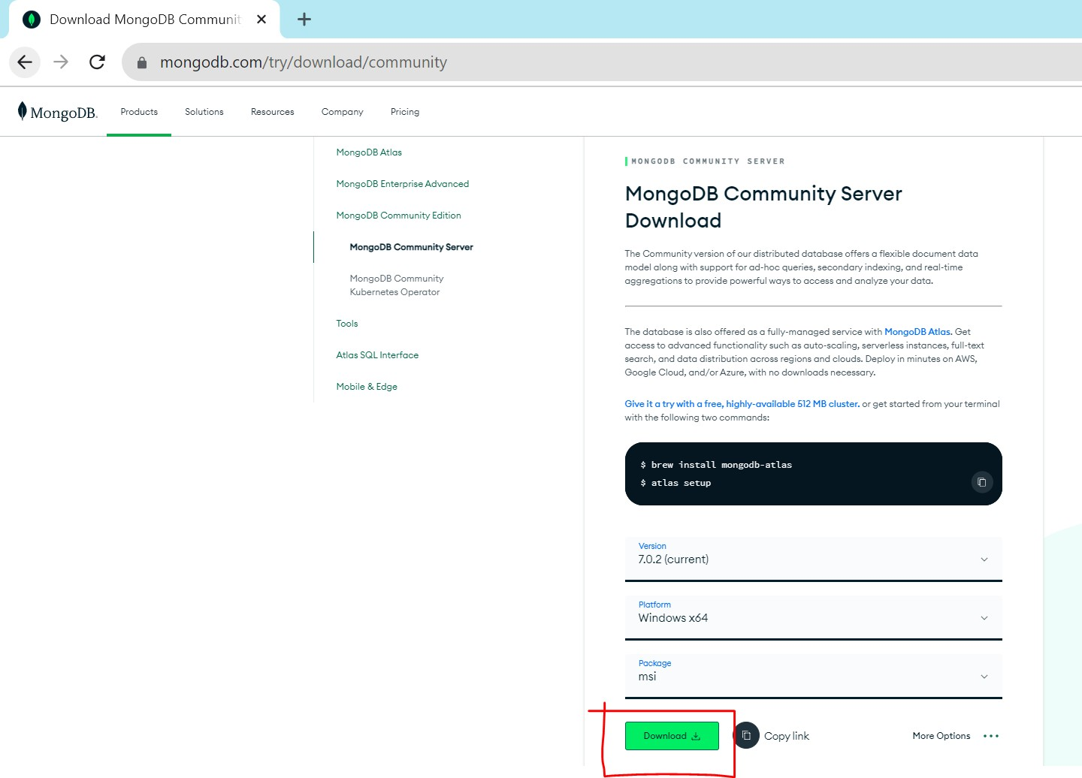

**Download MongoDB Shell Download** [**https://www.mongodb.com/try/download/shell**](https://www.mongodb.com/try/download/shell)

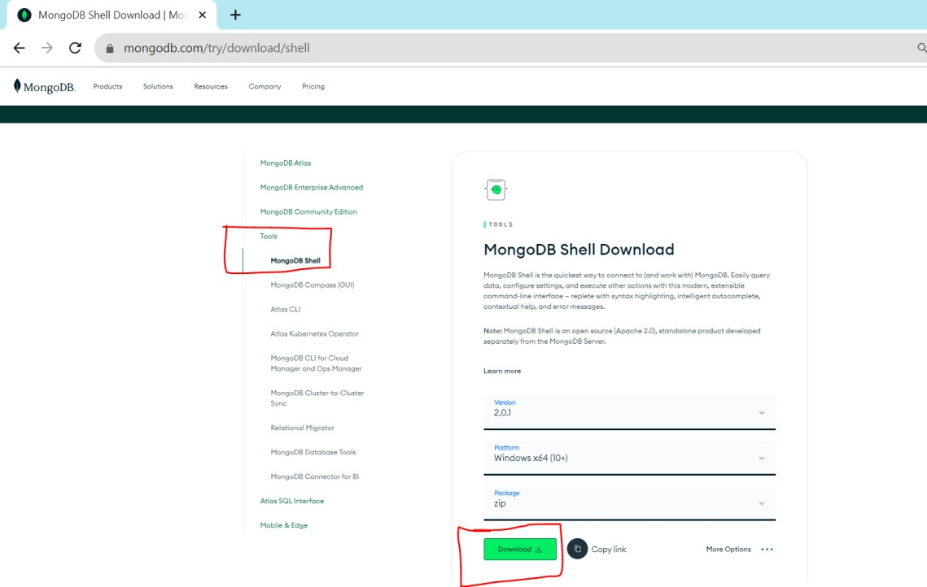

**MangoDB -Assignment 1**

**Design and Develop MangoDB queries using CRUD operation (Use CRUD operation Save Method and Logical Operator.**

In earlier versions of MongoDB, there used to be a function in the MongoDB

**save()**

shell that could be used to save or update documents in a collection. However, this function is now deprecated in recent versions of MongoDB (starting with version 3.2) and has been removed in MongoDB 4.0 and later versions. Instead, it's recommended to use the more specific insert, update, and replace operations to work with documents in collections.

test> use ass10; switched to db ass10 ass10>

ass10> db.createCollection("Library");

{ ok: 1 }

ass10> db.library.insert({"bid":1,"name":"C++"});

{

acknowledged: true,

insertedIds: { '0': ObjectId("65191fe647ff05b0c6ab5250") }

}

ass10> db.library.insert({"bid":2,"name":"java"});

{

acknowledged: true,

insertedIds: { '0': ObjectId("6519201947ff05b0c6ab5251") }

}

ass10> db.library.insert({"bid":3,"name":"Python"});

{

acknowledged: true,

insertedIds: { '0': ObjectId("6519204047ff05b0c6ab5252") }

}

ass10> db.library.find()

|  |  |  |  |  |  |  |
| --- | --- | --- | --- | --- | --- | --- |
| [ |  |  |  |  | | |
|  | { | _id: | ObjectId("65191fc147ff05b0c6ab524f") }, |
|  | { | _id: | ObjectId("65191fe647ff05b0c6ab5250"), bid: | 1, | name: | 'C++' }, |
|  | { | _id: | ObjectId("6519201947ff05b0c6ab5251"), bid: | 2, | name: | 'java' }, |
|  | { | _id: | ObjectId("6519204047ff05b0c6ab5252"), bid: | 3, | name: | 'Python' } |
| ] |  |  |  |  |  |  |

ass10> db.library.find().pretty(); [

|  |  |  |  |  |  |  |
| --- | --- | --- | --- | --- | --- | --- |
|  | { | _id: | ObjectId("65191fc147ff05b0c6ab524f") }, |  | | |
| { | _id: | ObjectId("65191fe647ff05b0c6ab5250"), bid: | 1, | name: | 'C++' }, |
| { | _id: | ObjectId("6519201947ff05b0c6ab5251"), bid: | 2, | name: | 'java' }, |
| { | _id: | ObjectId("6519204047ff05b0c6ab5252"), bid: | 3, | name: | 'Python' } |
| ] |  |  |  |  |  |  |

ass10> db.library.update({"name":"Python"},{$set:{"name":"Python3.7"}})

DeprecationWarning: Collection.update() is deprecated. Use updateOne, updateMany, or bulkWrite.

{

acknowledged: true, insertedId: null, matchedCount: 1,

modifiedCount: 1,

upsertedCount: 0

}

ass10> db.library.find() [

{ _id: ObjectId("65191fc147ff05b0c6ab524f") },

{ _id: ObjectId("65191fe647ff05b0c6ab5250"), bid: 1, name: 'C++' },

{ _id: ObjectId("6519201947ff05b0c6ab5251"), bid: 2, name: 'java' },

{

_id: ObjectId("6519204047ff05b0c6ab5252"), bid: 3,

name: 'Python3.7'

}

]

ass10> db.library.remove({"bid":1});

DeprecationWarning: Collection.remove() is deprecated. Use deleteOne, deleteMany, findOneAndDelete, or bulkWrite.

{ acknowledged: true, deletedCount: 1 }

ass10> db.library.find() [

{ _id: ObjectId("65191fc147ff05b0c6ab524f") },

{ _id: ObjectId("6519201947ff05b0c6ab5251"), bid: 2, name: 'java' },

{

_id: ObjectId("6519204047ff05b0c6ab5252"), bid: 3,

name: 'Python3.7'

}

]

ass10> db.library.find({"name":"java"})

[ { _id: ObjectId("6519201947ff05b0c6ab5251"), bid: 2, name: 'java' } ] ass10> db.library.insert({"bid":4,"name":"java","desc":"fake book"});

{

acknowledged: true,

insertedIds: { '0': ObjectId("6519224647ff05b0c6ab5253") }

}

ass10> db.library.find() [

{ _id: ObjectId("65191fc147ff05b0c6ab524f") },

{ _id: ObjectId("6519201947ff05b0c6ab5251"), bid: 2, name: 'java' },

{

_id: ObjectId("6519204047ff05b0c6ab5252"), bid: 3,

name: 'Python3.7'

},

{

_id: ObjectId("6519224647ff05b0c6ab5253"), bid: 4,

name: 'java', desc: 'fake book'

}

]

ass10> db.library.find({"name":"java"}); [

{ _id: ObjectId("6519201947ff05b0c6ab5251"), bid: 2, name: 'java' },

{

_id: ObjectId("6519224647ff05b0c6ab5253"), bid: 4,

name: 'java', desc: 'fake book'

}

]

ass10> db.library.find({$and:[{"name":"java"},{"desc":"fake book"}]}) [

{

_id: ObjectId("6519224647ff05b0c6ab5253"), bid: 4,

name: 'java', desc: 'fake book'

}

]

ass10> db.library.find({$or:[{"name":"java"},{"desc":"fake book"}]}) [

{ _id: ObjectId("6519201947ff05b0c6ab5251"), bid: 2, name: 'java' },

{

_id: ObjectId("6519224647ff05b0c6ab5253"),

bid: 4,

name: 'java', desc: 'fake book'

}

]

ass10> db.library.find({$or:[{"name":"java"},{"name":"Python3.7"}]}) [

{ _id: ObjectId("6519201947ff05b0c6ab5251"), bid: 2, name: 'java' },

{

_id: ObjectId("6519204047ff05b0c6ab5252"), bid: 3,

name: 'Python3.7'

},

{

_id: ObjectId("6519224647ff05b0c6ab5253"), bid: 4,

name: 'java', desc: 'fake book'

}

]

ass10> db.library.insert({"bid":4,"name":"my story","cost":500});

DeprecationWarning: Collection.insert() is deprecated. Use insertOne, insertMany, or bulkWrite.

{

acknowledged: true,

insertedIds: { '0': ObjectId("65192b1e1890f8d9ebe31230") }

}

ass10> db.library.find(); [

{ _id: ObjectId("65191fc147ff05b0c6ab524f") },

{ _id: ObjectId("6519201947ff05b0c6ab5251"), bid: 2, name: 'java' },

{

_id: ObjectId("6519204047ff05b0c6ab5252"),

bid: 3,

name: 'Python3.7'

},

{

_id: ObjectId("6519224647ff05b0c6ab5253"), bid: 4,

name: 'java', desc: 'fake book'

},

{

_id: ObjectId("65192b1e1890f8d9ebe31230"), bid: 4,

name: 'my story', cost: 500

}

]

ass10> db.library.insert({"bid":4,"name":"my story","cost":800});

{

acknowledged: true,

insertedIds: { '0': ObjectId("65192b3c1890f8d9ebe31231") }

}

ass10> db.library.insert({"bid":4,"name":"my story2.0","cost":800});

{

acknowledged: true,

insertedIds: { '0': ObjectId("65192b4a1890f8d9ebe31232") }

}

ass10> db.library.insert({"bid":4,"name":"my story beta version","cost":800});

{

acknowledged: true,

insertedIds: { '0': ObjectId("65192b551890f8d9ebe31233") }

}

ass10> db.library.find(); [

{ _id: ObjectId("65191fc147ff05b0c6ab524f") },

{ _id: ObjectId("6519201947ff05b0c6ab5251"), bid: 2, name: 'java' },

{

_id: ObjectId("6519204047ff05b0c6ab5252"), bid: 3,

name: 'Python3.7'

},

{

_id: ObjectId("6519224647ff05b0c6ab5253"), bid: 4,

name: 'java', desc: 'fake book'

},

{

_id: ObjectId("65192b1e1890f8d9ebe31230"), bid: 4,

name: 'my story', cost: 500

},

{

_id: ObjectId("65192b3c1890f8d9ebe31231"), bid: 4,

name: 'my story', cost: 800

},

{

_id: ObjectId("65192b4a1890f8d9ebe31232"), bid: 4,

name: 'my story2.0', cost: 800

},

{

_id: ObjectId("65192b551890f8d9ebe31233"), bid: 4,

name: 'my story beta version', cost: 800

}

]

ass10> db.library.find({"cost":{$gte:100}}) [

{

_id: ObjectId("65192b1e1890f8d9ebe31230"), bid: 4,

name: 'my story', cost: 500

},

{

_id: ObjectId("65192b3c1890f8d9ebe31231"), bid: 4,

name: 'my story', cost: 800

},

{

_id: ObjectId("65192b4a1890f8d9ebe31232"), bid: 4,

name: 'my story2.0', cost: 800

},

{

_id: ObjectId("65192b551890f8d9ebe31233"), bid: 4,

name: 'my story beta version', cost: 800

}

]

ass10> db.library.find({"cost":{$gte:500}})

[

{

_id: ObjectId("65192b1e1890f8d9ebe31230"), bid: 4,

name: 'my story', cost: 500

},

{

_id: ObjectId("65192b3c1890f8d9ebe31231"), bid: 4,

name: 'my story', cost: 800

},

{

_id: ObjectId("65192b4a1890f8d9ebe31232"), bid: 4,

name: 'my story2.0', cost: 800

},

{

_id: ObjectId("65192b551890f8d9ebe31233"), bid: 4,

name: 'my story beta version', cost: 800

}

]

ass10> db.library.find({"cost":{$gte:600}}) [

{

_id: ObjectId("65192b3c1890f8d9ebe31231"), bid: 4,

name: 'my story', cost: 800

},

{

_id: ObjectId("65192b4a1890f8d9ebe31232"), bid: 4,

name: 'my story2.0', cost: 800

},

{

_id: ObjectId("65192b551890f8d9ebe31233"), bid: 4,

name: 'my story beta version', cost: 800

}

]

ass10> db.library.find({"cost":{$in:[100,200,500]}}) [

{

_id: ObjectId("65192b1e1890f8d9ebe31230"), bid: 4,

name: 'my story', cost: 500

}

]

ass10> db.library.find({"cost":{$nin:[100,200,500]}}) [

{ _id: ObjectId("65191fc147ff05b0c6ab524f") },

{ _id: ObjectId("6519201947ff05b0c6ab5251"), bid: 2, name: 'java' },

{

_id: ObjectId("6519204047ff05b0c6ab5252"), bid: 3,

name: 'Python3.7'

},

{

_id: ObjectId("6519224647ff05b0c6ab5253"), bid: 4,

name: 'java', desc: 'fake book'

},

{

_id: ObjectId("65192b3c1890f8d9ebe31231"), bid: 4,

name: 'my story', cost: 800

},

{

_id: ObjectId("65192b4a1890f8d9ebe31232"), bid: 4,

name: 'my story2.0', cost: 800

},

{

_id: ObjectId("65192b551890f8d9ebe31233"), bid: 4,

name: 'my story beta version', cost: 800

}

]

**MangoDB Assignment 2**

**Implement aggregation and indexing with suitable example using MongoDB**

//USE DATABASE

* use comp; switched to db comp

//CREATE COLLECTION WEBSITE

* db.createCollection('website');

{ "ok" : 1 }

//INSERT VALUES IN WEBSITE

* db.website.insert({'roll':'1','name':'harsh','amount':1000,'ur l':'www.yahoo.com'});

WriteResult({ "nInserted" : 1 })

>db.website.insert({'roll':'2','name':'jitesh','amount':2000,'url':'www.yah oo.com '});

WriteResult({ "nInserted" : 1 })

>db.website.insert({'roll':'3','name':'rina','amount':3000,'url':'www.googl e.com' });

WriteResult({ "nInserted" : 1 })

>db.website.insert({'roll':'4','name':'ash','amount':4000,'url':'www.gmail. com'}) ;

WriteResult({ "nInserted" : 1 })

>db.website.insert({'roll':'5','name':'ash','am[ount':1000,'url':'www.pvg.co](http://www.pvg.co/) m'});

WriteResult({ "nInserted" : 1 })

//SUM AGGREGATE

* db.website.aggregate({$group:{_id:"$name","total":{$sum:"$amount"}}});

{ "_id" : "ash", "total" : 5000 }

{ "_id" : "rina", "total" : 3000 }

{ "_id" : "jitesh", "total" : 2000 }

{ "_id" : "harsh", "total" : 2000 }

//AVG AGGREGATE

* db.website.aggregate({$group:{_id:"$name","total": {$avg:"$amount"}}});

{ "_id" : "ash", "total" : 2500 }

{ "_id" : "rina", "total" : 3000 }

{ "_id" : "jitesh", "total" : 2000 }

{ "_id" : "harsh", "total" : 1000 }

//MIN AGGREGATION

* db.website.aggregate({$group:{_id:"$name","total":{$min:"$amount"}}});

{ "_id" : "ash", "total" : 1000 }

{ "_id" : "rina", "total" : 3000 }

{ "_id" : "jitesh", "total" : 2000 }

{ "_id" : "harsh", "total" : 1000 }

//MAX AGGREGATION

* db.website.aggregate({$group:{_id:"$name","total":{$max:"$amount"}}});

{ "_id" : "ash", "total" : 4000 }

{ "_id" : "rina", "total" : 3000 }

{ "_id" : "jitesh", "total" : 2000 }

{ "_id" : "harsh", "total" : 1000 }

//FIRST AGGREGATION

* db.website.aggregate({$group:{_id:"$name","total":{$first:"$amount"}}});

{ "_id" : "ash", "total" : 4000 }

{ "_id" : "rina", "total" : 3000 }

{ "_id" : "jitesh", "total" : 2000 }

{ "_id" : "harsh", "total" : 1000 }

//LAST AGGREGATION

* db.website.aggregate({$group:{_id:"$name","total":{$last:"$amount"}}});

{ "_id" : "ash", "total" : 1000 }

{ "_id" : "rina", "total" : 3000 }

{ "_id" : "jitesh", "total" : 2000 }

{ "_id" : "harsh", "total" : 1000 }

//PUSH AGGREGATION

* db.website.aggregate({$group:{_id:"$name","total": {$push:"$amount"}}});

{ "_id" : "ash", "total" : [ 4000, 1000 ] }

{ "_id" : "rina", "total" : [ 3000 ] }

{ "_id" : "jitesh", "total" : [ 2000 ] }

{ "_id" : "harsh", "total" : [ 1000, 1000 ] }

//COUNT AGGREGATION

* db.website.aggregate({$group:{_id:"$name","total": {$sum:1}}});

{ "_id" : "ash", "total" : 2 }

{ "_id" : "rina", "total" : 1 }

{ "_id" : "jitesh", "total" : 1 }

{ "_id" : "harsh", "total" : 2 }

//ADDTOSET AGGREGATE

* db.website.aggregate({$group:

{_id:"$name","total"{$addToSet:"$amount"}}});

{ "_id" : "ash", "total" : [ 1000, 4000 ] }

{ "_id" : "rina", "total" : [ 3000 ] }

{ "_id" : "jitesh", "total" : [ 2000 ] }

{ "_id" : "harsh", "total" : [ 1000 ] }

//INDEXING

* db.createCollection('website1'); { "ok" : 1 }
* db.website1.insert({'r':1,'name':'harsh'}); WriteResult({ "nInserted" : 1 })
* db.website1.find().pretty()

{ "_id" : ObjectId("5ba3509a444926329738012d"), "roll" : 1, "name" : "harsh" } { "_id" : ObjectId("5ba35293444926329738012e"), "roll" : 1, "name" : "harsh" }

* db.website1.createIndex({'name':1})

{ "numIndexesBefore" : 2, "note" : "all indexes already exist", "ok" : 1 }

//CREATE INDEXING

* db.website1.createIndex({'name':-1})

{ "createdCollectionAutomatically" : false, "numIndexesBefore" : 2, "numIndexesAfter" : 3, "ok" : 1 }

* db.website1.getIndexses()

2018-09-20T13:28:09.628+0530 TypeError: Property 'getIndexses' of object om.website is not a function

* db.website1.getIndexes()

[ {"v" : 1, "key" : { "_id" : 1 }, "name" : "_id_", "ns" : "harsh.website1"

},

{ "v" : 1, "key" : { "name" : 1 }, "name" : "name_1", "ns" : "harsh.website1" },

{ "v" : 1, "key" : { "name" : -1 }, "name" : "name_-1", "ns" : "harsh.website1" } ]

* db.website1.createIndex({'name':-1})

{ "numIndexesBefore" : 3, "note" : "all indexes already exist", "ok" : 1 }

//DROP INDEX

* db.website.dropIndex({'name':-1})

{ "nIndexesWas" : 3, "ok" : 1 }> db.website1.dropIndex({'name':1})

{ "nIndexesWas" : 2, "ok" : 1 }> db.website1.dropIndex({'name':1})

{ "nIndexesWas" : 1, "ok" : 0, "errmsg" : "can't find index with key:{ name: 1.0 }" }

//GET INDEXING

* db.website1.getIndexes() [ { "v" : 1, "key" : { "_id" : 1 }, "name" : "_id_", "ns" : "harsh.website1" } ]
* db.website1.find().pretty()

{ "_id" : ObjectId("5ba3509a444926329738012d"), "roll" : 1, "name" : "harsh" }

{ "_id" : ObjectId("5ba35293444926329738012e"), "roll" : 1, "name" : "harsh" }

* db.website1.createIndex({'name':1})

{ "createdCollectionAutomatically" : false, "numIndexesBefore" : 1, "numIndexesAfter" : 2, "ok" : 1 }

* db.website1.getIndexes()

[ { "v" : 1, "key" : { "_id" : 1 }, "name" : "_id_", "ns" : "harsh.website1" },

{ "v" : 1, "key" : {"name" : 1 }, "name" : "name_1", "ns" : "harsh.website1" } ]

* db.website1.dropIndex({'name':1})

{ "nIndexesWas" : 2, "ok" : 1 }

* db.website1.getIndexes()

[ { "v" : 1, "key" : { "_id" : 1 }, "name" : "_id_", "ns" : "harsh.website1" } ]

* db.website1.createIndex({'name':1,'r':-1})

{"createdCollectionAutomatically" : false, "numIndexesBefore" : 1, "numIndexesAfter" : 2, "ok" : 1 }

* db.website1.getIndexes()

[ { "v" : 1, "key" : { "_id" : 1 }, "name" : "_id_", "ns" : "harsh.website1" },

{ "v" : 1, "key" : { "name" : 1, "r" : -1 }, "name" : "name_1_r_-1", "ns" : "harsh.website1" } ] (i- search)`db.website1.insert({'roll':1,'name':'harsh'});':

**MangoDB Assignment 3**

**Implement Map reduces operation with suitable example using MongoDB**

* db.createCollection('Journal');

{ "ok" : 1 }

>db.Journal.insert({'book_id':1,'book_name':'JavacdOOP','amt':500,'status': 'A vailable'}); WriteResult({ "nInserted" : 1 })

>

db.Journal.insert({'book_id':1,'book_name':'JavaOOP','amt':400,'status':'No t Available'}); WriteResult({ "nInserted" : 1 })

>db.Journal.insert({'book_id':1,'book_name':'Java','amt':300,'s tatus':'Not Available'});

WriteResult({ "nInserted" : 1 })

>db.Journal.insert({'book_id':2,'book_name':'Java','amt':300,'s tatus':'Available'});

WriteResult({ "nInserted" : 1 })

>db.Journal.insert({'book_id':2,'book_name':'OPP','amt':200,'st atus':'Available'});

WriteResult({ "nInserted" : 1 })

>db.Journal.insert({'book_id':2,'book_name':'C+','amt':200,'status':'Availa ble'} );

WriteResult({ "nInserted" : 1 })

>db.Journal.insert({'book_id':3,'book_name':'C+','amt':150,'status':'Availa ble'} );

WriteResult({ "nInserted" : 1 })

* db.Journal.insert({'book_id':3,'book_name':'C+ +','amt':200,'status':'Not Available'});

WriteResult({ "nInserted" : 1 })

* db.Journal.insert({'book_id':4,'book_name':'OPP C+

+','amt':300,'status':'Not Available'}); WriteResult({ "nInserted" : 1 })

* db.Journal.insert({'book_id':5,'book_name':'OPP C+

+','amt':400,'status':'Available'}); WriteResult({ "nInserted" : 1 })

* db.Journal.insert({'book_id':5,'book_name':'C+

+','amt':400,'status':'Available'}); WriteResult({ "nInserted" : 1 })

* db.Journal.insert({'book_id':5,'book_name':'C++ Java','amt':400,'status':'Not Available'}); WriteResult({ "nInserted" : 1

})

* var mapfunction=function(){ emit(this.book_id,this.amt)};
* var reducefunction=function(key,value){return Array.sum(value);};
* db.Journal.mapReduce(mapfunction,reducefunction, {'out':'new'});

{ "result" : "new",

"timeMillis" : 49,"counts" : { "input" : 12,

"emit" : 12,

"reduce" : 4,

"output" : 5

}, "ok" : 1 }

* db.new.find().pretty();

{ "_id" : 1, "value" : 1200 }

{ "_id" : 2, "value" : 700 }

{ "_id" : 3, "value" : 350 }

{ "_id" : 4, "value" : 300 }

{ "_id" : 5, "value" : 1200 }